*Updated on December 11, 2024*

Contents

**Introduction** 1

**Before Cohort Start Date:** Submit Funding Metrics Form in CO Portal 1

**Week 1 of Delivery:** Submit Delivery Metrics Intake Survey in CO Portal 2

**After Graduation:** Submit Certification Exam Metrics Form in CO Portal 3

**After Graduation:** Submit Placement Metrics in CO Portal 4

**Automated Metrics:** Learners Engaged and Learners Trained 7

**Reporting Issues with Metrics** 7

# **Introduction**

Collaborating Organizations (COs) regularly report metrics to AWS*. Instructions can be found below:

# **Before Cohort Start Date:** Submit Funding Metrics Form in CO Portal

Metrics Lead and/or Main Point of Contact (MPOC) can complete the [Funding Metrics Form](https://www.awsrestartprogram.com/s/form-submission/funding-metrics-form) as an optional means of reporting how AWS re/Start cohort delivery is funded by the CO.

**What is this data used for?** This data may be used to understand how AWS re/Start is funded externally so that AWS can work with COs to expand funding opportunities.

|  |  |  |
| --- | --- | --- |
| Metrics | Where does this come from? | Notes/Comments |
| Collaborating Organization (CO) Name | **Funding Metrics Form:** CO Name | Automatically populated |
| Country of Delivery (COD) | **Funding Metrics Form:** Picklist of countries where CO is delivering AWS re/Start | Please select the primary Country of Delivery for the cohort/s that will be funded |
| Type of Funding Source | **Funding Metrics Form:** Picklist of funding source   * Foundation * Multi-National (e.g. United Nations) * Central Government (e.g. National) * Self-Funded (by the Collaborating Organization) * Corporate Sponsorship (e.g. Corporate Gift) * Regional (e.g. Province, State, County) * Local (e.g. Municipal, Council, City) | Please select one type of funding source |
| Amount from Funding Source | **Funding Metrics Form:** Amount of funding received | Please enter the amount of funding received |
| Currency of Funding Source | **Funding Metrics Form:** Picklist of currency of funding source | Please select the currency of the funding received |
| Date Funding Received | **Funding Metrics Form:** Date the funding was received | Please select the date the funding has or will be received |
| Duration of Funding | **Funding Metrics:** Number of months of funding duration | Please enter the number of months for which the funding was awarded |
| Type of Funding | **Funding Metrics Form:** Picklist of type of funding   * One-Time Funding * Pilot Funding * Recurring Funding | Please select one type of funding |
| Funding Parameters | **Funding Metrics Form:** Picklist (multi-select) of funding parameters   * Audience-Specific * Co-Funding or Match Funding * Job Placements Required * Location * Other * None | Please select all the applicable funding parameters |
| Will this be used in any other Country of Delivery? | **Funding Metrics Form:** Picklist of countries where CO is delivering AWS re/Start |  |
| Notes | **Funding Metrics Form:** Free type | Please do not include any personal data (for example, names or contact information of individuals). |

# **Week 1 of Delivery:** Submit Delivery Metrics Intake Survey in CO Portal

Metrics Lead and/or Main Point of Contact (MPOC) can complete the [Delivery Metrics Intake Survey](https://www.awsrestartprogram.com/s/metrics) as an optional means of reporting how many applicants apply to AWS re/Start, as well as how many women and underrepresented minorities participate in AWS re/Start.

**What is this data used for?** This anonymized and aggregated cohort-level data may be used to identify delivery, funding, and placement opportunities for AWS re/Start at local, national, or regional levels.

|  |  |  |
| --- | --- | --- |
| Metrics | Where does this come from? | Notes/Comments |
| Candidates Applied | **Delivery Metrics Intake Survey:** Number of candidates applied | COs report this to AWS as a number, anonymized and aggregated by cohort. |
| Women Enrolled (self-reported) | **Delivery Metrics Intake Survey:** Number of women enrolled (self-reported) | Learners must have the option to select “Prefer not to answer.” These numbers must be self-reported by learners to the CO, then reported to AWS, anonymized and aggregated by cohort. |
| Didn’t Report Gender | **Delivery Metrics Intake Survey:** Total number of enrolled learners who did not report gender | COs report this to AWS as a number, anonymized and aggregated by cohort. If gender reporting is not conducted, list the total number of learners enrolled in this field. Otherwise, list the total number of responses which said, “Prefer not to answer.” |
| Under-Represented (self-reported) | **Delivery Metrics Intake Survey:** Number of learners of under-represented minority (self-reported) | Please observe all relevant reporting laws and regulations in your location. If ethnicity reporting is conducted, learners must have the option to select “Prefer not to answer”. These numbers must be self-reported by learners to the CO in a questionnaire provided by the CO. If reporting is conducted, COs report this to AWS as a number, anonymized and aggregated by cohort. |
| Didn’t Report Under-Represented Status | **Delivery Metrics Intake Survey:** Total number of enrolled learners who did not report ethnicity | Please observe all relevant reporting laws and regulations in your location.  If ethnicity reporting is not conducted, list the total number of learners enrolled in this field. Otherwise, list the total number of responses which said, “Prefer not to answer.” |

# **After Graduation:** Submit Certification Exam Metrics Form in CO Portal

Metrics Lead, Course Coordinator, and/or Main Point of Contact (MPOC) should complete the Certification Exam Metrics Form as a means of reporting how many AWS re/Start learners scheduled the AWS Certification Exam and how many AWS re/Start learners passed the AWS Certification Exam.

**What is this data used for?** This anonymized and aggregated cohort-level data is used to understand how many learners achieved AWS Cloud Practitioner Certification as an outcome of AWS re/Start.

|  |  |  |
| --- | --- | --- |
| Metrics | Where does this come from? | Notes/Comments |
| Learners Scheduled AWS Certification Exam | **Certification Exam Metrics Form:** Number of learners who have scheduled the AWS Certification Exam | Learners reported to the CO that they scheduled the AWS Certification Exam. COs report this to AWS as a number, anonymized and aggregated by cohort. |
| Learners Passed AWS Certification Exam | **Certification Exam Metrics Form:** Number of learners who have passed the AWS Certification Exam | Learners reported to the CO that they passed the AWS Certification Exam. COs report this to AWS as a number, anonymized and aggregated by cohort. |

# **After Graduation:** Submit Placement Metrics in CO Portal

To report placements**, please navigate to the [Placement Form](https://www.awsrestartprogram.com/s/placement) where you have the option to either:

1. Have an MPOC, Course Coordinator, or Metrics Lead submit a "Bulk Upload" document containing multiple placement outcomes document (recommended for submitting 10+ placement outcomes at one time)
2. Any member of the CO may individually enter placement details through filling out the fields on this page.

Both methods of entering placement data will result in the placement outcomes being reflected in the "Analytics Tab” in the CO Portal.

**What is this data used for?** This anonymized data is used to understand how many learners were placed into jobs as an outcome of AWS re/Start. Details of those job placements are used to understand which jobs AWS re/Start learners are connected to so that the program can continue to drive job placements for AWS re/Start graduates.

|  |  |  |
| --- | --- | --- |
| Metrics | Where does this come from? | Notes/Comments |
| Cohort ID | **Placement Form or Bulk Upload Template:** Cohort ID |  |
| Placement Country | **Placement Form or Bulk Upload Template:** Placement Country | Please select only from available list of options. Free text is not supported. |
| Placement City | **Placement Form or Bulk Upload Template:** Placement City |  |
| Employer Name | **Placement Form or Bulk Upload Template:** Employer Name |  |
| Role Title | **Placement Form or Bulk Upload Template:** Role Title |  |
| Role Type | **Placement Form or Bulk Upload Template:** Role Type | Please select only from available list of options. Free text is not supported. |
| Placement Type | **Placement Form or Bulk Upload Template:** Placement Type | Please select only from available list of options. Free text is not supported. |
| Placement Start Date | **Placement Form or Bulk Upload Template:** Placement Start Date | In case the Placement Start Date is unknown, kindly use the date this form is filled out as a substitute. |
| Placement Connection Source | **Placement Form or Bulk Upload Template:** Placement Connection Source | Please select only from available list of options. Free text is not supported. |
| Placement Wage Rate | **Placement Form or Bulk Upload Template:** Placement Wage Rate | Optional |
| Placement Wage Currency | **Placement Form or Bulk Upload Template:** Placement Wage Currency | Optional. Please select only from available list of options. Free text is not supported. |
| Placement Wage Period | **Placement Form or Bulk Upload Template:** Placement Wage Period | Optional. Please select only from available list of options. Free text is not supported. |
| Comment | **Placement Form or Bulk Upload Template:** Comment | Optional |

If you are reporting 10 or more placements at once, you may prefer to use the “Bulk Upload” option rather than individually reporting placements via the Placement Form. If using “Bulk Upload,” please follow the steps below:

**Step 1:** Select the “Bulk Upload for Placements” button on the [Placement Form](https://www.awsrestartprogram.com/s/placement) page.

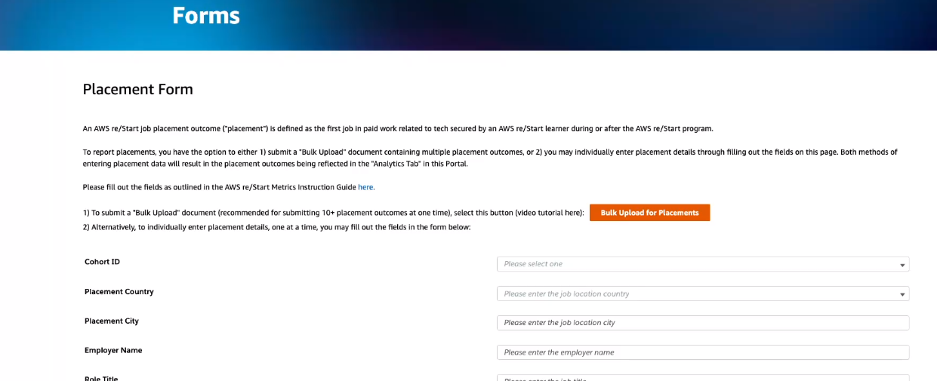

**Step 2:** You will see the screen below. Select “Download Template.”

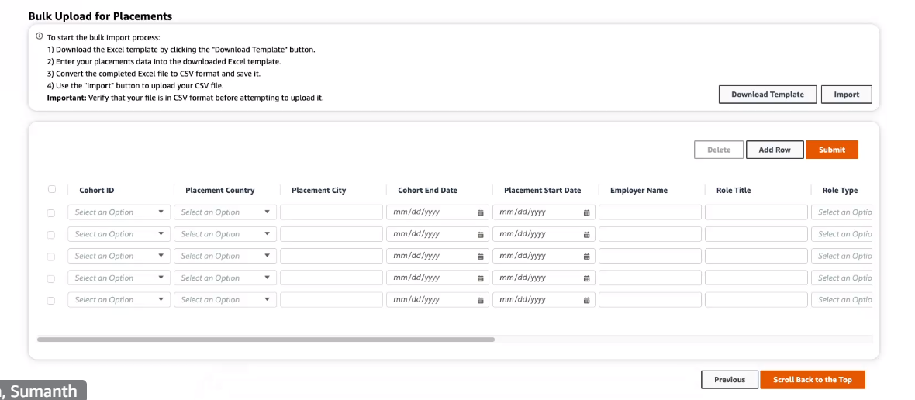

**Step 3:** Open the downloaded .csv file and follow the steps as outlined on the “Instructions” tab.

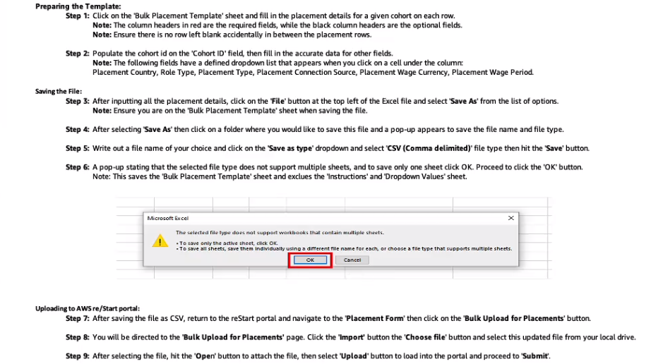

**Note:** By selecting the “Bulk Placement Template” tab in the .csv file, you will see the following columns to fill out.

# 

# **Automated Metrics:** Learners Engaged and Learners Trained

|  |  |  |
| --- | --- | --- |
| Metrics | Where does this come from? | Notes/Comments |
| Learners Engaged | **Canvas:** Number of learners who accepted the Canvas invitation and agreed to the AWS Education Program Learner Terms and Conditions |  |
| Learners Trained | **Canvas:** Number of learners who met the AWS re/Start program graduation criteria | Trained metrics are automated for all cohorts starting July 8, 2024 and after |

# **Reporting Issues with Metrics**

Please report any issues or submit any questions regarding metrics to the [AWS Support Form here](https://support.aws.amazon.com/#/contacts/aws-restart).

*\* All metrics reported through the AWS re/Start Collaborating Organization Portal should be anonymized and aggregated at the cohort level. Please do not include any personal data (for example, names or contact information of individuals). Also, please observe applicable laws and regulations related to data reporting in your location.*

*\*\* Placement is defined as work related to tech during or after the AWS re/Start program. This includes full time jobs, contract positions, paid internships, apprenticeships, part time jobs, and freelancer/entrepreneur positions. The AWS re/Start program celebrates the career success of all learners, regardless of the time it takes to secure their first technical role. Please record the first eligible job for all AWS re/Start learners by completing the ‘*[Placement Form](https://www.awsrestartprogram.com/s/placement)*’ in the ‘Forms’ section of the CO Portal.*